**Project Design Phase-II**

**Technology Stack (Architecture & Stack)**

|  |  |
| --- | --- |
| Date | 26 October 2022 |
| Team ID | PNT2022TMID19165 |
| Project Name | Project - xxx |
| Maximum Marks | 4 Marks |

**Technical Architecture:**

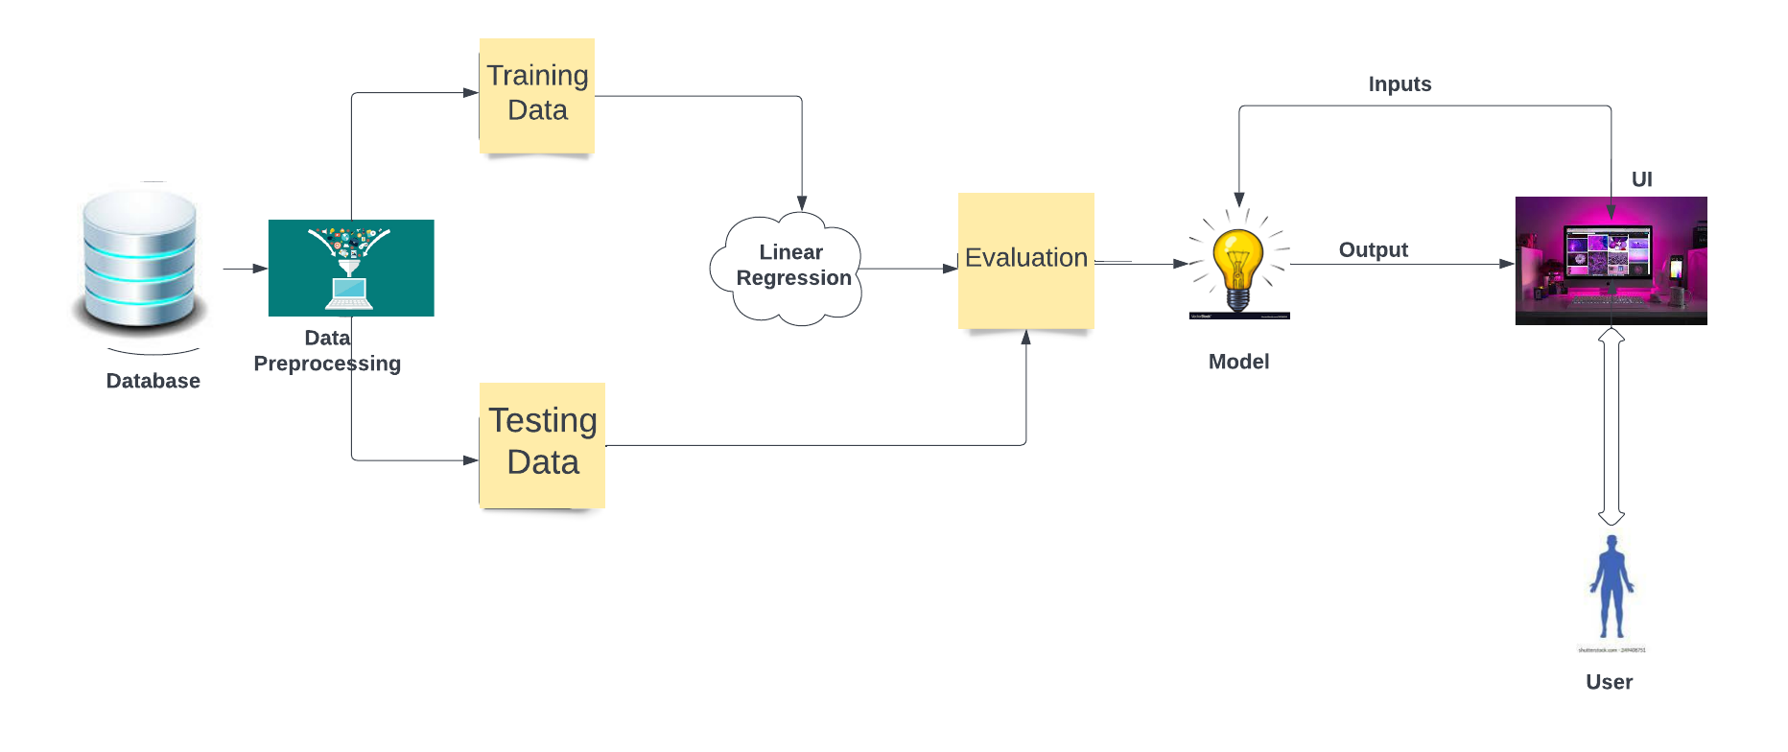

**Table-1 : Components & Technologies:**

|  |  |  |  |
| --- | --- | --- | --- |
| **S.No** | **Component** | **Description** | **Technology** |
|  | User Interface | Application interact with Web UI | HTML, CSS, JavaScript |
|  | Application Logic-1 | Clean the dataset to fill the missing value and remove unwanted data. | Python |
|  | Application Logic-2 | Load the model and initialize Flask app. To fetch the parameter values from the UI, and return the prediction. | Python |
|  | Application Logic-3 | To take the values from the user in a form and upon clicking on the button for submission it has to redirect to URL for “y_predict” which returns the predicted resale value | HTML,CSS,Python |
|  | Cloud Database | Database Service on Cloud | IBM cloudant |
|  | File Storage | Storage Requirements | IBM Block Storage or Other Storage Service or Local Filesystem |
|  | File Storage | File storage requirements | IBM Block Storage or Other Storage Service or Local Filesystem |
|  | External API-1 | Weather API is used in the application | IBM Weather API, etc. |
|  | External API-2 | External API used | HTTP request |
|  | Machine Learning Model | To improve the predictive accuracy and control over-fitting. | Linear Regression, Python |
|  | Infrastructure (Server / Cloud) | Application Deployment on Local System / Cloud  Local Server Configuration:  Cloud Server Configuration : | Heroku Platform |

**Table-2: Application Characteristics:**

| **S.No** | **Characteristics** | **Description** | **Technology** |
| --- | --- | --- | --- |
|  | Open-Source Frameworks | To establish an connection between the flask and an HTML page. | Python Flask |
|  | Security Implementations | Protects User information as well as their car details. | SHA-256, Encryptions. |
|  | Scalable Architecture | The website can be visited by both desktop and mobile phones. | Web UI,Mobile Android app |
|  | Availability | The website can be accessed all the time. | IBM Cloud |
|  | Performance | The model performance has high accuracy and with portable from one machine to another machine. | HTML,CSS |

**References:**

[**https://www.irjet.net/archives/V8/i5/IRJET-V8I5490.pdf**](https://www.irjet.net/archives/V8/i5/IRJET-V8I5490.pdf)

[**https://smartinternz.com/guided-project/car-resale-value-prediction**](https://smartinternz.com/guided-project/car-resale-value-prediction)